Data analysis of the

XENON100 Experiment



Therreau Chloé

Project Supervisor: M.P Decowski
Nikhef- National institute for subatomic physics
Science Park 105

1098 XG Amsterdam


Résumé
Depuis la fin du dernier siècle, plusieurs observations astrophysiques ont montré qu'une grande partie de la masse de l'univers est composée d'une substance que l'on ne peut détecter, appelée la matière noire. Ces observations ont, en réalité, montré que 85% de la masse de l'univers est sous forme de matière noire. Depuis, les physiciens ont développé plusieurs expériences pour détecter cette matière « invisible ». Même si la matière noire n'a toujours pas été découverte, la sensibilité de ces expériences de détection a été grandement améliorée. De nouvelles expériences, avec une plus grande sensibilité, doivent voir le jour dans les prochaines décennies.
L'expérience XENON100 est une expérience de détection direct de la matière noire qui utilise du xénon liquide pour détecter des interactions entre une particule de matière noire et un atome de xénon. Pendant deux mois, j'ai travaillé sur l'analyse de données de cette expérience.
Ce rapport est une introduction à la matière noire et en particulier, une présentation de l’expérience XENON100. Je présente également mon travail effectué sur l'analyse de données du détecteur XENON100.
Abstract
In the last century, several astrophysical observations showed that a large part of the universe's mass is composed of something we have not detected until now: dark matter. Actually, these observations showed that 85% of the mass of the universes is dark matter. Since these observations, physicists had developed several experiments to detect this “invisible” matter. Even if dark matter have not been discovered yet, the sensitivity of direct and indirect detection experiments has been highly improved in the past decade [4]. New experiments with a greater sensitivity are planned for the next decade.
The XENON100 Experiment is a direct detection experiment using liquid xenon in a time projection chamber to detect interactions between a dark matter particle and a xenon atom. For two months, I worked on the data analysis of XENON100.
This paper is an introduction to dark matter and more precisely a presentation of the XENON100 experiment. I also present my work on the data analysis of the XENON100 detector.

Contents
Part One: Two months in Nikhef 5
Part Two: Dark matter 6
I) What is the dark matter? 6
II) Detection of dark matter 8
1) Production 8
2) Indirect Detection 9
3) Direct Detection 9
Part Three: The XENON100 experiment 11
I) Description of the detector 11
1) Liquid Xenon LXe 11
2) Photomultipliers 11
3) The dual phase time projection chamber 12
II) Data analysis software used in Nikhef 14
Part Four: Light Collection Efficiency Map 16
I) Why do we need a light collection efficiency map? 16
II) Cesium source 17
1) Cesium 137 17
2) Photoelectric and Compton effect 17
3) First Analysis 18
III) Light collection efficiency Map 21
1) Selection of the events form the photopeak 21
a) The combined Energy Scale 22
b) The cS2 bottom signal 22
c) Determination of the combined energy scale 26
26
2) After Selected the photopeak? 26
Conclusion 27
List of Figures 28
Bibliography 29
Annexe 30

Part One: Two months in Nikhef

Nikhef, the national institute for subatomic physics is located in Science Park Amsterdam, in the Netherlands. Nikhef is lead by Stan Bentvelsen since 2014.
Nikhef is a partnership between the Foundation for Fundamental Research on Matter (FOM), which is part of the Netherlands Organization for Scientific Research, and five universities: Radboud University, the University of Groningen, the University of Amsterdam, Utrecht University and VU University. The name of Nikhef originates from the original name “National Institute for Nuclear Physics and High Energy Physics”.
The Nikhef's primary mission is to coordinate and lead the Dutch experimental activities on particle and astroparticle physics with 10 different research groups:
- Astrophysics groups: Dark Matter, Cosmic Rays, Neutrino Telescopes and Gravitational Waves.
- Particle physics groups: ALICE, ATLAS and LHCb (All three are LHC experiments).
- Other research projects groups: Detector R&D, Grid Computing and Theoretical Physics.
The knowledge and technology transfer is another one of Nikhef's missions. [11]
I did my internship in the dark matter group lead by Patrick Decowski. This group is a part of the XENON project which is a collaboration of 21 institutions across the world and representing 24 nationalities.
During this internship, I worked on the data analysis of the XENON100 experiment under the supervision of two PhD students: Sander Breur and Erik Hogenbirk. After studying the XENON100 detector and the data analysis software used in the dark matter group, I worked on the light collection efficiency map of the XENON detector (see Part Four).
One of the main objectives of this internship was to learn how to work in a team. Indeed, I had the opportunity to attend group meetings every week. I also had to make several presentations of the progress of my work in front of the entire group during these meetings. In addition, I had the opportunity to work with others students on the data analysis the new dark matter experiment: XENON1T.

Part Two: Dark matter

Fig. 1: Distribution of the universe's mass [1]. 85 % of the universe's mass is dark matter.

I) What is the dark matter?
The existence of dark matter was introduced to explain several astrophysics observations which indicate the presence of a missing mass in the universe. The distribution of the universe's mass is represented in the fig.1 [1]

One of these is the observation of the rotational velocity of spirals galaxies.
Stars rotate around the center of the galaxy. The rotational velocity of these stars is related to the gravitational force and therefore related to the mass of the galaxy. Indeed, the velocity is related to the centripale force which compensates the gravitational force. If we take the example of a galaxy which has the major part of its mass in its center, we should see the velocity of the stars decreases when the distance between the star and the center of the galaxy increases. However, the measurements of the rotational velocity as a function of the distance between stars and the center of the galaxy do not give this theoretical repartition as shown in Fig.2.
Fig.2 shows a large discrepancy between observation and theory. The experimental rotation curves are “flat”, indicating that the rotational velocity of stars is roughly constant with the distance between stars and the center of the galaxy. The gravitational force required for these rotational velocities must come from an unknown form of massive matter that surrounds each galaxy: dark matter.
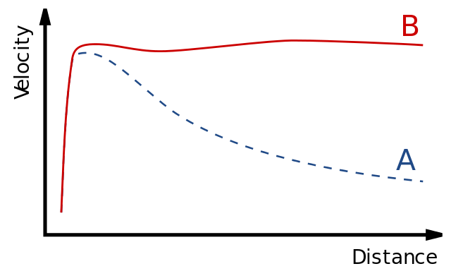
Fig. 2:Shape of rotational curve of a typical spiral galaxy [2]
“Distance” is the distance of stars from the center of the galaxy. “Velocity” is the rotational velocity of stars.
The difference between theoretical and observed curve is caused by a dark matter halo that surrounds the galaxy.

A : theoretical curve based on the visible mass of the galaxies

B: curve based on observations
There are other arguments that prove the existence of a missing mass in the universe like the gravitational lens effect. This effect is caused by the deviation of light by a massive object. Thanks to it, the quantity of galaxies' mass can be directly measured, showing the existence of missing matter in the universe [1][3].
If we consider dark matter exists, the next question is: of what is made this dark matter? One of the theory is dark matter is composed of particles. According to what we just said, these particles have certain properties:
- be massive (to explain that 85% the universe's mass is dark matter)
- have a neutral charge (charged particles are easy to detect by their interactions with standard matter)
- be weakly interacting (otherwise scientists would have already detect them by their interactions with particles of the standard model).
The Weakly Interactive Massive Particles (WIMPs) are candidates for playing the role of dark matter particles.

II) Detection of dark matter
Several scientific collaborations have been tried to prove the existence of dark matter by three different ways: indirect detection, direct one and production at colliders.
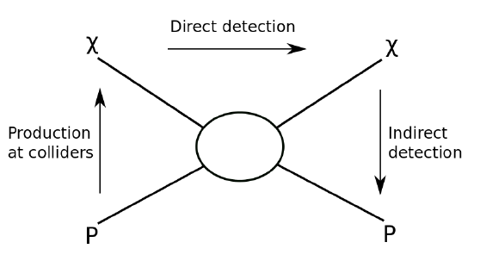
Fig. 3: Schematic showing the possible dark matter detection channels [4]
χ : dark matter particle ; p : standard particle. The arrows show the direction of reactions.

Fig.3 can be represented as:
where

1) Production

One way to detect dark matter is to create it in collider like the LHC, based on (3). Because dark matter particles are weakly interacting, they pass through the detector without interacting. However, these particles have an energy. This energy taken by dark matter is “missing” when the total expected energy is compared to the total measured energy. A difference like this would thus indicate the existence of dark matter.

2) Indirect Detection
Indirect detection is based on the fact that dark matter particles can interact with each others and can be annihilated in standard model particles, such as γ-rays, that can be detect (2).

However, the dark matter density is low, and therefore, the annihilation of two dark matter particles have a very low probability. Besides, γ-rays are very common in the universe. That is why scientists have to look at area of the universe where dark matter is dense (to increase the probability of interaction) and where the background created by γ-rays is low. [5]
VERITAS, HESS, MAGIC (and many others [6]) are examples of indirect detection experiments.

3) Direct Detection
The earth is in the Milky Way, our galaxy, and like all the other galaxies in the universe, the Milky Way is surrounded by a halo of dark matter. When the earth rotates around the Sun which also moves in the galaxy, particles of dark matter pass through the earth. Direct detection experiments try to “see” collisions between dark matter particles and standard particles (1) :

However, it is difficult to detect a collision between a detector and dark matter particles for several reasons :
- First, dark matter particles are weakly interacting. There are very few collisions between them and the detector.
- Secondly, the background from cosmic rays is high compared to the expected event rate for dark matter. That is why this detector is placed deep underground (to shield it from cosmic radiation). But, an other issue appears: the natural radioactivity of the ground, of the detector materials and the intrinsic detector radioactivity emit standard particles (such as γ-rays, α and β particles..). These particles can interact with the detector. Cosmic radiation and natural radioactivity is the background signal. To avoid this background, radio-pure materials (with low uranium and thorium content) and a large detector shielding are used. [4]
- Finally, even if the background is significantly reduced, some particles (like neutrons) can go through the shielding and interact with the detector. To discriminate neutrons from WIMPs, we have to use knowledge about the expected WIMP signal:

    - Because of the sun's rotation around the center of the galaxy and the rotation of the earth around the sun, the velocity of the earth in the halo of dark matter is not the same during the year: in June the Earth's velocity will add to the sun's velocity whereas in December, the velocities are opposite. Therefore, the flux of dark matter particles should be maximal in June and minimal in December [7][3]. Dark matter should have a yearly modulation, while background signal should stay the same.
    - Collisions between dark matter and detector give three way of possible signals (Fig.4): production of heat as phonon, scintillation (light produced by excitation and subsequent de-excitation of the target nucleus) and ionization of atoms (electrons). Direct detection experiment usually use two of these three possible signals [4][8].
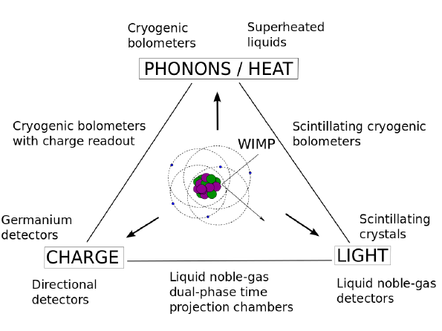Fig. 4: Schematic of possibles signals that can be measured in direct detection experiments depending on the technology in use [4]

CDMS (Germanium detector and silicon bolometers), DAMA (scintillator crystals), DarkSide (liquid argon), XENON (liquid xenon) are examples of direct detection experiments [8].

Part Three: The XENON100 experiment

I) Description of the detector
The XENON100 detector is placed at the Laboratori Nazionai del Gran Sasso, in Italy. It is a cylindrical dual phase time-projection chamber (TPC) with 62 kg of liquid xenon with a layer of gas above and 242 photomultiplier tubes (PMT) divided between two arrays of PMTs [10].

1) Liquid Xenon
Liquid xenon was chosen for this experiment for several reasons. First, it gives a homogeneous target with a large density that increases the probability of interaction with a dark matter particle. Then, liquid xenon has a high ionization and scintillation (de-excitation of an atoms) yields. In addition, the scintillation light of xenon has a wavelength of 175 nm and therefore can be directly detect using PMT (sensitive to ultraviolet light) [4] [11]. Liquid xenon is also transparent to its scintillation light.

2) Photomultiplier tubes
A photomultiplier tube (PMT) is a vacuum tube made of a photocathode, several dynodes and an anode. PMT are used to detect photons (from the ultraviolet to the infrared, depends on the material used).When a photon hits the photocathode, an electron is produce by photo-electric effect. When this first electron hits the first dynode, other electrons are emitted and these electrons hit the second dynode. Finally, the electrons at the output have enough charge to produce a measurable signal [14]
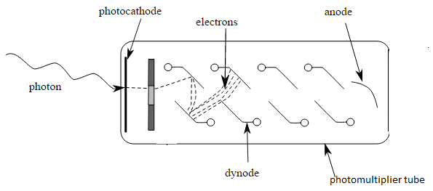
Fig. 5: Scheme of a photomultiplier tube [15]
Photons generate electrons by photoelectric effect on the photocathode. A series of dynode amplifies the signal.

3) The dual phase time projection chamber
When a particle (γ-ray or WIMP for example) hits the liquid xenon, xenon atoms are ionized and excited. The excited xenon atoms will recombine with an other xenon atom, forming an excited molecular state that will decay to an unexcited state. During this de-excitation, the first scintillation signal, S1, is emitted. The S1 signal can be directly detected by the photomultiplier tubes. In the same time, some of the electrons coming from the ionization of xenon escape the recombination and are guided to the gas phase by an electrical field. A second stronger electrical field extracts the electrons from the liquid phase to the gas phase, generating a light signal: the secondary scintillation signal, called S2. [9][13]
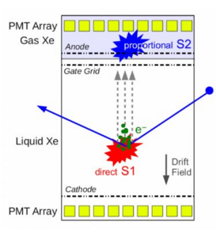Fig. 6: Functional principal of the XENON100 detector [9]. A WIMP interact with liquid xenon in the TPC, generating S1 and S2 signals.
WIMP

One of the advantages of using a time projection chamber is that this detector allows a 3-dimensional reconstruction of the interaction. The x-y position is determined by the S2 signal. Indeed, this signal is right above the localisation of the interaction, and is close to the top PMT array. Thereby, the position of the S2 signal in the top PMT array gives a precise x-y position, since the quantity of measured light depends on the position on the TPC (see part four). The z position is determined by the time difference between the S1 and the S2 signal, called the drift time which is proportional to the distance travelled on the TPC [15]
Another advantage is that the time projection chamber allows us to discriminate a WIMP interaction from other particle interactions. Indeed, S1 and S2 signals have not the same characteristics if they come from an interaction between liquid xenon and a WIMPs or if they come from an interaction between liquid xenon and a standard particle. WIMPs (and neutrons) are expected to cause nuclear recoil in the liquid xenon while γ-ray (for example) are expected to cause electronic recoil. Thereby, WIMP and γ-ray do not product the same quantity of light and ionization as shown in Fig.7.
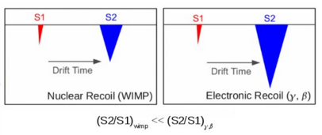

Fig. 7: Ratio difference between WIMP interaction and background noise interaction [9]
Electronic and Nuclear recoil do not give the same S1-S2 ratio, allowing discrimination between WIMPs and background signal.

Others methods are used to reduce the background noise. First, a large shielding surrenders the detector. Indeed, it is placed 10 000 meters under the Gran Sasso mountain in Italy to reduce the cosmics radiation background [11]. Secondly, the detector is encircled with 99kg of liquid xenon used as an active scintillator veto (to ignore a signal created by a cosmic radiation). The detector is also placed into a cryostat, surround by layer of copper, polyethylene, lead and water [13]. Finally, since the time-projection chamber permits the positioning of the interaction, the radioactivity background can be reduce knowing that radioactivity background is most likely at the edge of the detector [9].
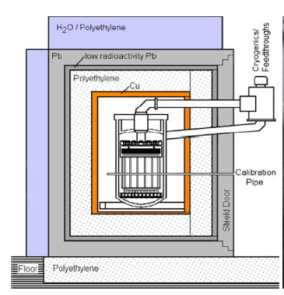Fig. 8: Shielding of the XENON100 detector [13]

II) Data analysis software used in Nikhef
Since the XENON detector is compounded of 242 photomultiplier tube (PMT), it collects a lot of raw data.
When a PMT detects a photon, a pulse can be observed surrounded by a baseline. A digitizer permits to exclude the baseline from the data, leaving only the pulses. At this point, the data is composed of a lot of pulses coming from each PMT. To organize this raw data, we use PAX (Processor for Analyzing XENON). PAX finds the hits of each pulse for each PMT. After that, PAX clusters the hits in peaks then it computes and classifies the properties of each peaks, given S1 peaks or S2 peaks. Here, PAX creates a ROOT file containing our processed data, as shown in Fig.10. Afterward, HAX (Handy Analysis tools for XENON) allows us to extract data from the ROOT file and make small ones (called miniTree) which contain just the data we want to analyze [16]. A basic minitree is automaticely created when we use HAX. If we want other information, we have to create our own minitree that will call information contain in the “pax event class”:
http://xenon1t.github.io/pax/format.html
Fig. 9: Pax logo

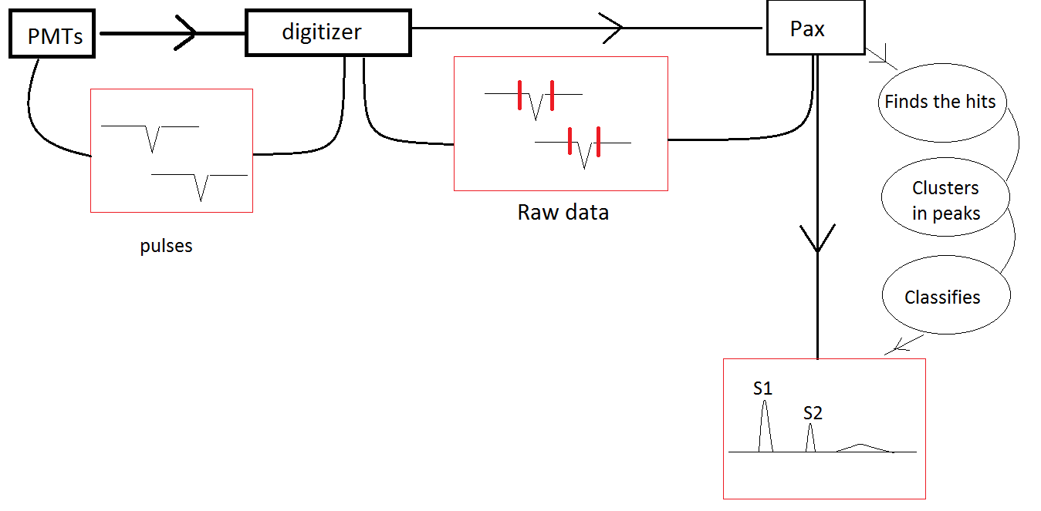

Fig. 10: Functional schema of PAX. The data flow are pulses surrounded by a baseline. A digitizer permits to exclude the baseline from the data, leaving only the pulses. Then, the data are processed by PAX.

Part Four: Light Collection Efficiency Map
During my internship, I analyzed data taken with radioactive Cesium sources placed next to the XENON100 detector. These data are used to create a light collection efficiency map.

I) Why do we need a light collection efficiency map?
For a given energy deposition, the quantity of light measured depends on the position of the interaction in the time projection chamber. Indeed, there are several effects that affect the light collection efficiency, for example:
- the reflectivity of the TPC: when an interaction occurs, photons go in all direction, can be reflected on the wall of the TPC and therefore can distort the data when reflected photons hit the PMTs.
- the impurities: a photon emitted after an interaction can be absorbed by impurities in the xenon, reducing the observed signal.
- the solid angle effect: if photons are emitted close to the PMT array, the solid angle covered by these PMT becomes smaller, reducing the observed signal.
- the Rayleigh scattering: an elastic scattering of light occurs when the radiation hits particles smaller than its wavelength, and gives a smaller measured energy.
These effects, that affect both S1 and S2 signals, depend only on the properties of the detector and are the reason why we need a map of the light collection efficiency to correct the data. To do this map, several radioactive sources were used and placed at different positions around the detector [15] [17]. A first version of this map is shown in Fig.11.
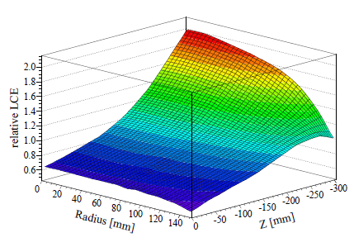Fig. 11: Correction map for the light collection efficiency. The measured S1 signals are divided by the values from this map[15].

II) Cesium source

1) Cesium 137
In the remainder of the paper, we will analyze data taken with ¹³⁷ Cs source placed next to the detector. The Cesium 137 is a radioactive element with a half-live of 30 years. The cesium 137 is a β- emitter. It decays, with a probability of 94,6%, to a metastable state of Barium 137m. The ^{137m} Ba has a half-life of 2,5 min. When it decays to its stable state, it emits a γ-ray with an energy of 661,7 keV. [18]
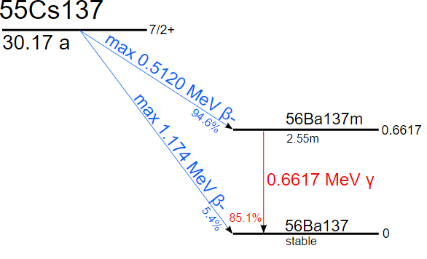Fig. 12: Cs137 Decay Scheme [18]

2) Photoelectric and Compton effect
When a γ-ray collides with atom, several effect can occur: the photo-electric effect, Compton scattering and pair production (if the initial γ-ray has an energy superior to 1,022 MeV). With a Cesium source, γ-rays are emitted with an energy of 661,7 keV: the pair production can not happen.
The Photoelectric effect occurs when a γ-ray collides with an electron of the detector material. This electron is ejected and takes all the energy of the photon. In the case of the XENON100 detector, the ejected electron will excite and ionize xenon atom, generating S1 and S2 signal. The measured energy spectrum of S1 and S2 will have a photoelectric peak at the energy of the initial γ-ray, as shown in Fig. 13. For the Cesium source, we expected a photo-electric peak at 661,7 keV.
In this case of Compton scattering, the γ-ray does not give all its energy to the electron. The photon scatters on the electron, transferring part of its energy. The scattered photon has a lower energy and can product other effects until it is absorbed. As a consequence, the measured energy spectrum will have a continuous distribution of energy, as shown in Fig. 13.

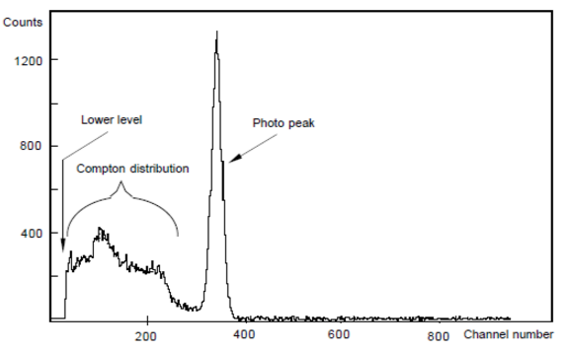Fig. 13: Energy spectrum expected with photoelectric and Compton effects [19]

3) First Analysis
To start our analysis, we are going to look at data taken with a Cesium source placed next to the detector. We start with basic plots, using data given by the Basics Minitree of HAX (see the code in appendix).
In Fig. 14 and 15, each point is one event, the color bar shows the number of events. The first plot, Fig. 14, is a x against y histogram showing us that the most part of the events occurs on the right of the detector. We can see that the source was placed on the right of the detector. The second plot, Fig. 15, is a S1 against z and a S1 against r² histogram, with r²=x²+y². This plot shows that the S1 signal depends on the position of the interaction, like we expected. The third plot, Fig. 16, is an energy spectrum of both S1 and cS1 signal. The x axis is in pe (photoelectron), unit proportional to the deposed energy in the PMTs: the more powerfull the signal is, the more photoelectrons are created in the photocatode. CS1 is the corrected S1 signal. It was corrected by the light collection efficiency map shown in Fig.11. These plots show that the photopeak of cS1 has a better resolution than the photopeak of S1, but the energy resolution can be approve (see part III).
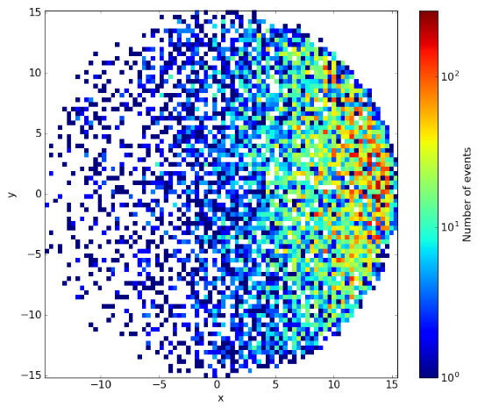

Fig. 14: x against y histogram, the number of events is showed by the color bar. The Cesium source was on the right of the detector.
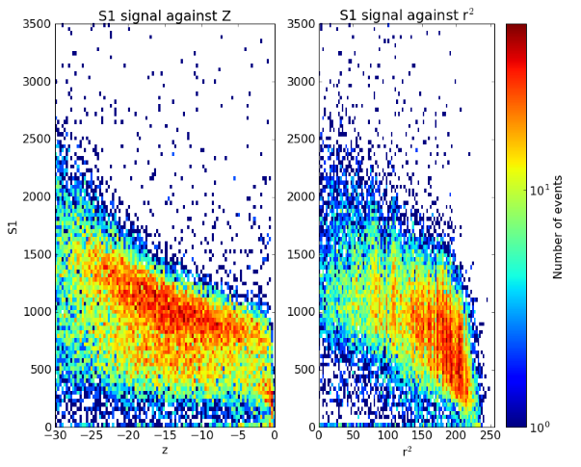

Fig. 15: S1 against z and r² histogram, the number of event is showed by the color bar. The quantity of measured light depends on the position of the interaction in the TPC.
Photopeak

Compton distribution
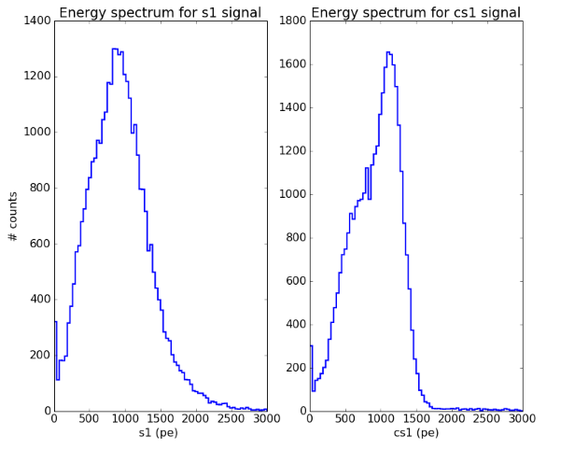

Fig. 16: Energy spectrum for S1 and cS1 signal (pe is for photoelectron). The Cesium photopeak can be seen in these too spectrums.

III) Light Collection Efficiency Map
To make a light collection efficiency map, the energy deposited in the TPC had to be precisely known. That is why we need to select events that only come from the photopeak, that means with a known energy of 662 keV.

1) Selection of the events form the photopeak
Fig. 17 shows the corrected signal S1 vs the corrected signal S2, on a logarithm scale. In this pot, we can see a red “point” that indicts a lot of events: the photopeak. The rest of the event forms a “cloud” below the photopeak, due to the Compton scattering.
Photopeak

Compton effect
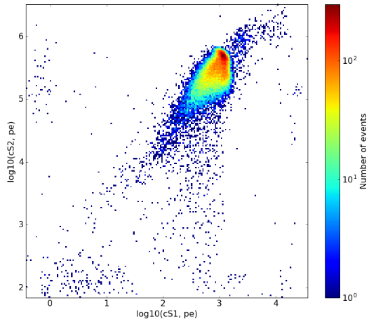

Fig. 17: cS1 against cS2 histogram (pe is for photoelectron). The photopeak is the red point.
Now, we want to select only the photopeak's events. However, like we see in the precedent paragraph, the photopeak of the cS1 signal is broad: the energy resolution is low. Therefore, we can not used it to select photopeak's events. The same issue occurs for the cS2 signal. That, we are going to use the combined energy scale to improve the energy resolution.

a) The combined Energy Scale
S1 and S2 are anti-correlated. This anti-correlation is due to the fact that scintillation (S1) occurs as ionization recombines, but S2 is proportional to the ionization (see part three I)3.). Then, the electrical field applied in the TPC modifies this recombination and therefore changes the proportion between light (S1) and ionization (S2), but the sum of these two values, called the combined energy scale (CES), is constant.[20][21]

b) The cS2 bottom signal
To calculate the combined energy scale, we are going to use the “cS1” and “cS2_tot_bottom” signals.

cS2_tot_bottom is the corrected area of the S2 signal measured by the bottom array of photomultipliers. However, the Basic Minitree of HAX give us only the s2_area_top_fraction, that means the fraction of the area of the S2 signal measured by the top array of photomultiplier, and the cS2, that means the corrected area of the S2 signal, measured by both top and bottom PMTs array. Thereby, we can calculate cs2_tot_bottom by:

We use cS2_tot_bottom because it give a more precise energy than the cS2 signal, as shown in Fig.18. Indeed, the S2 signal is created near the top PMT array (in the gas phase), therefore, the saturation of the PMTs are more likely than if the signal was created further from the PMT array. When a PMT is saturated, the energy information is lost, given an imprecise measured energy.
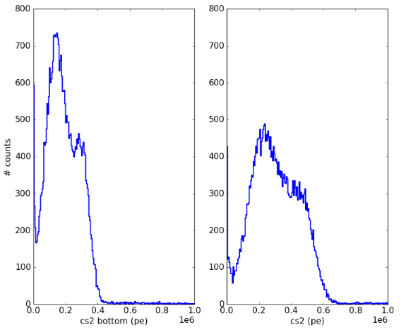Fig. 18: Energy spectrum for cS2_tot_bottom and cS2 (pe is for photoelectron). CS2 bottom have a better resolution energy than cS2

In Fig.19, we plot cS1 vs cS2_tot_bottom, with the radius position of the interaction r² in colorbar. In this plot, we still see our photopeak. But, we also clearly see an other population. This population have the same cS1 but a lower cS2_tot_bottom than the population coming from photopeak. Besides, we can see that this population is mostly in the center of the TPC.
The Fig.20 is an energy spectrum for cS2_tot_bottom and cS2 for regular and background data. In Fig. 21 we compare cS1 vs cS2_tot_bottom with r² in colorbar for regular and background data. Based on these plots, we can conclude that our unknown population is not due to background signal.

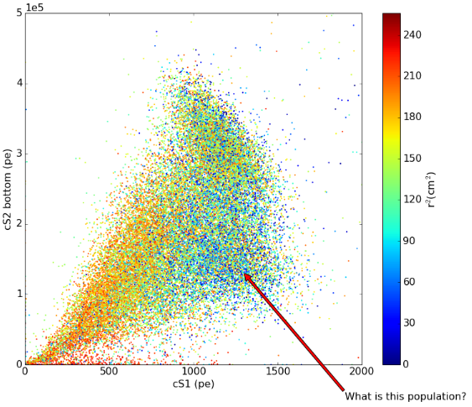

Fig. 19: cS1 against cS2_tot_bottom, r² is on the colorbar. Dot in blue means the interaction occurred in the center of the TPC, dot in red means that the interaction occurred at the edge of the TPC.
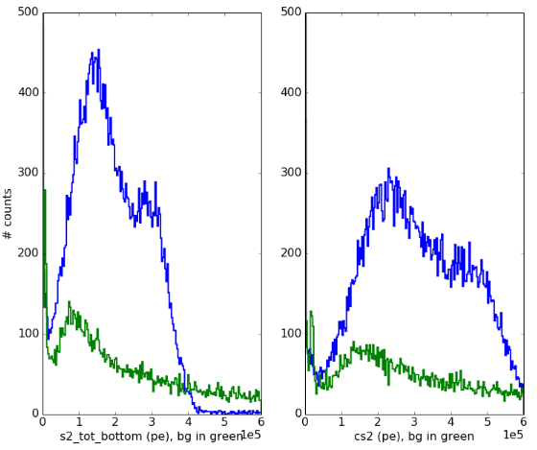

Fig. 20: Energy spectrum for cS2_tot_bottom and cS2 in blue, compared to background signal in green (pe is for photoelectron)

Actually, our unknown population is due to the double scatters events. When a Compton scattering happens, the original photon creates a S1 and S2 signal. Then, the scattered photon can also create another S1 and S2 signal. Both S1 signals are detected by the PMTs in the same time, since speed light in the TPC is higher than the detection speed of the PMTs. However, since the S2 signals are created after the travel of electrons, the PMT array will detect two S2 signals. For PAX, only the biggest S2 signal corresponds to the measured S1 signal and is classified as a S2 signal. As a consequence, a large part of S2 signal are missed, given a population with a low S2 and a high S1.
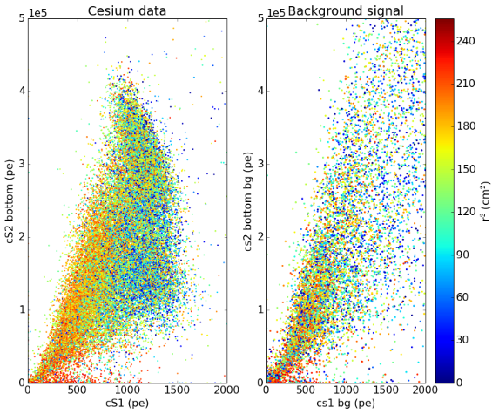

Fig. 21: cS1 against cS2_tot_bottom for regular data and background signal, r² is on the colorbar. Background signal can not explain the unknown population.
If we cut this double scatters events from the data, the unknown population disappears, as shown in Fig.22. To do the cut, we use the “largest_other_s2”, which gives the energy of signals that look like S2 signald but are not classified as S2 signals. In the case of a double scatter event, the largest_other_s2 will be important, thus we cut events with a large largest_other_s2 (see appendix).

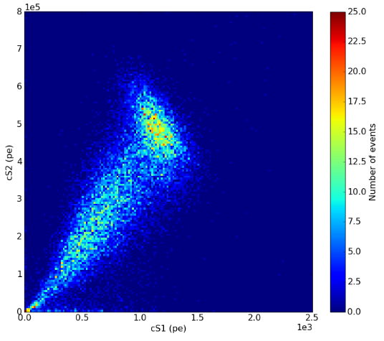
Fig. 22 : cS1 against cS2_tot_bottom histogram after the double scatters events cut, the number of events is showed in the color bar. The unknown population was cut.

c) Determination of the combined energy scale
The combined energy scale is the projection of the cS1 and the cS2_tot_bottom energies along the large axis of the ellipse formed in the cS1 against cs2_tot_bottom plan. To do this projection, we need to determined the angle of anticorrelation between cS1 and cS2_tot_bottom. We fit a two dimensional Gaussian function to the data, shown in Fig.23, using a code made by Erik Hogenbirk (see appendix). The final combined energy scale (CES) is shown in Fig.24. In Fig.25, we can see that CES have a better energy resolution than cS1 and cS2_tot_bottom.
In Fig.25 => ENERGIE RESOLUTION

Fig. 23: Fitting of the data using a two dimensional Gaussian function. The combined energy scale is the projection of cS1 and cS2_tot_bottom energies along the large axis of the ellipse.

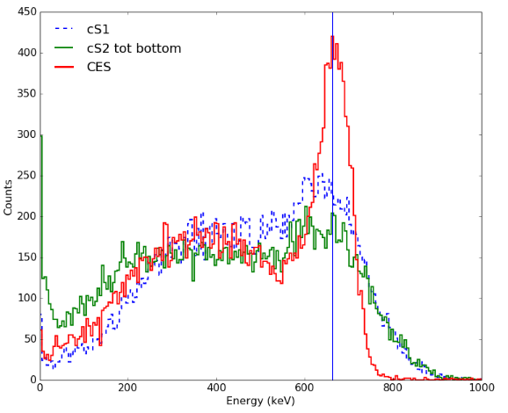Fig. 24: Combined Energy Scale spectrum, compared to cS1 and cS2_tot_bottom spectrum. CES have a better energy resolution than cS1 and cS2_tot_bottom.

2) After Selected the photopeak?

Conclusion

The purpose of my internship in Nikhef was to improve the light collection efficiency map of the XENON100 detector using a Cesium source. I should, in the next 2 weeks, reach this objective.
I first had to learn how data analysis software used in Nikhef, PAX, operated. Then only, I started working on data taken with a Cesium source placed next to the detector.
This internship was a rewarding professional experience. While learning how implement a scientific approach on the data analysis, this internship allowed me to discover the functioning of an international scientific collaboration. It also allowed me to improve my international skills, especially my scientific English, by talking about the XENON100 experiment with my colleagues, reading scientific articles, and doing oral presentation of my work in front of the dark matter group. I also had the opportunity to expand my computing skills, by learning a new programming language: Python.
Finally, this internship allowed me to glimpse the profession of researcher in experimental physics, and consolidate my professional project.

List of Figures

Fig. 1: Distribution of the universe's mass.

Fig. 2: Rotation curve of a typical spiral galaxies.

Fig. 3: Schematic showing the possible dark matter detection channels.

Fig. 4: Schematic of possible signals that can be measured in direct detection experiments depending on the technology in use.

Fig. 5: Photomultiplier Tube.

Fig. 6: Functional principal of the XENON100 detector.

Fig. 7: Ratio difference between WIMP interaction and background noise interaction.

Fig. 8: Shielding of the XENON100 detector.

Fig. 9: PAX logo.

Fig. 10: Functional schema of PAX.

Fig. 11: Correction map for the light collection efficiency. The measured S1 signals are divided by the values from this map.

Fig. 12: Cs-137 Decay Scheme.

Fig. 13: Energy spectrum expected with photoelectric and Compton effects.

Fig. 14: X vs Y histogram with a Cesium source.

Fig. 15: S1 vs Z and r² histogram with a Cesium source.

Fig. 16: Energy spectrum for S1 and cS1 signal (pe is for photoelectron).

Fig. 17: cS1 vs cS2 histogram (pe is for photoelectron).

Fig. 18: Energy spectrum for cS2_tot_bottom and cS2 (pe is for photoelectron).

Fig. 19: cS1 vs cS2_tot_bottom, r² is on the colorbar. Dot in blue means the interaction occurred in the center of the TPC, dot in red means that the interaction occurred at the edge of the TPC.

Fig. 20: Energy spectrum for cS2_tot_bottom and cS2, compared to background signal (pe is for photoelectron).

Fig. 21: cS1 vs cS2_tot_bottom for regular data and background signal, r² is on the colorbar.

Fig. 22: cS1 vs cS2_tot_bottom histogram after the double scatters events cut.

Fig. 23:

Fig. 24:

Fig. 25:

Bibliography

[1] BERTONE, Gianfranco, 2014, Le mystère de la matière noire, dans les coulisses de l'univers, Dunod, Quai des Sciences.

[2] Penn State: The rotation curve of the Milky Way:
https://www.e-education.psu.edu/astro801/content/l8_p8.html

[3] BOUQUET, Alain, MONNIER, Emmanuel, 2003, Matière noire et autres cachotteries de l'univers, Dumod, Quai des Sciences.

[4] T.Marrodan Undagoitia, L.Rauch, Hep-Ph(2015), arXiv:1509.08767, Dark matter direct-detection experiments, http://arxiv.org/pdf/1509.08767v1.pdf

[5] Jan Conrad, Hep-Ph (2014), arXiv:1411.1925, Indirect Detection of WIMP Dark Matter: a compact review, http://arxiv.org/abs/1411.1925

[6] ISAPP (Heidelbeg), Lectures, The Dark side of the Universe, Page 25,
https://www.mpi-hd.mpg.de/lin/events/isapp2011/pages/lectures/de_los_Heros.pdf

[7] TAILLET, Richard, La matière noire:
http://lapth.cnrs.fr/pg-nomin/taillet/dossier_matiere_noire/matiere_noire1.php

[8] M.Klasen, M.Pohl, G.Sigl, Hep-Ph(2015), arXiv:1507.03800, Indirect and direct search for dark matter, http://arxiv.org/abs/1507.03800

[9] Subatech: La recherche de la matière noire: http://www-subatech.in2p3.fr/fr/recherche/nucleaire-et-sante/xenon/recherche/fondamentales/xenon100

[10] BAUDIS L.,Astro-ph.IM (2012), arXiv:1203.1589v1, Results from the XENON100 Dark Matter Search Experiment: http://arxiv.org/abs/1203.1589

[11] Nikhef: https://www.nikhef.nl/en/science-technology/astroparticle-physics/donkere-materie/xenon-1t/#c1247

[12] Xenon Dark Matter Project: http://xenon.physik.uni-mainz.de/

[13] M. LE CALLOCH, these (2014), Study of the single electron charge signals in the XENON100 direct Dark Matter search experiment

[14] Wikipedia: Photomultiplier tube
https://en.wikipedia.org/wiki/Photomultiplier#Structure_and_operating_principles

[15] XENON100 Collaboration, astro-ph.IM (2012), arXiv:1107.2155, The XENON100 Dark Matter Experiment, http://arxiv.org/pdf/1107.2155.pdf

[16] XENON group notebooks: https://github.com/XENON1T

[17] BIN Choi, these (2013), The Light Response of the XENON100 Time Projection Chamber and the Measurements of the Optical Parameters with the Xenon Scintillation Light

[18] Wikipedia: Caesium 137, https://en.wikipedia.org/wiki/Caesium-137

[19] Web site: Gammadataeduction.ent: http://www.gammadata.net/sv/gammadata-utbildnings-webshop/utbildningsprodukter/faerdiga-laborationer-sv/measurement-of-a-gamma-ray-spectrum/

[20] EXO Collaboration, Hep-ex (2003), arXiv:0303008v1, Correlated Fluctuations between Luminescence and Ionization in Liquid Xenon, http://arxiv.org/pdf/hep-ex/0303008v1.pdf

[21] A. BEHRENS, these (2014), Light Detectors for the XENON100 and XENON1T

Appendix
You can find the commented code that I made to do this data analysis in the following link:

